Министерство образования Республики Беларусь

Учреждение образования

БелорусскиЙ государственный университет

информатики и радиоэлектроники

Факультет компьютерных систем и сетей

Кафедра программного обеспечения информационных технологий

|  |
| --- |
|  |
|  |

# оТЧЕТ

по лабораторной работе №5

|  |  |  |
| --- | --- | --- |
| Выполнил  Студент гр. 851002 |  | Жукова Е.А. |
| Проверил |  | Фадеева Е.Е. |
|  |  |  |
|  |  |  |
|  |  |  |
|  | Минск, 2021 |  |

**Работа турагентства**

1. Настройка прав доступа

|  |  |  |  |  |
| --- | --- | --- | --- | --- |
|  | Приложение | Гость | Пользователь | Администратор |
| tour | R | R | R | CRUD |
| tour_type | R | R | R | CRUD |
| tour_types_tours | R | R | R | CRUD |
| FAQ | R | R | R | CRUD |
| tour_day_description | R | R | R | CRUD |
| photo | R | R | R | CRUD |
| feedback | R | R | CRUD | CRUD |
| tour_date | R | R | R | CRUD |
| tours_ localities | R | R | R | CRUD |
| locality | R | R | R | CRUD |
| booking_group | R | - | CRUD | CRUD |
| country | R | R | R | CRUD |
| visa_information | R | R | R | CRUD |
| address | R | - | CRUD | CRUD |
| user | CRUD | R | CRUD | CRUD |
| booking | R | - | CRUD | CRUD |
| critical_contact | R | - | CRUD | CRUD |
| street | R | R | R | CRUD |
| service | R | R | R | CRUD |
| services_tours | R | R | R | CRUD |

SQL-код настройки прав доступа выглядит следующим образом:

DROP USER 'admin'@'localhost';

CREATE USER 'admin'@'localhost' IDENTIFIED BY 'adminpassword';

GRANT ALL PRIVILEGES ON * TO 'admin'@'localhost';

DROP USER 'guest'@'localhost';

CREATE USER 'guest'@'localhost' IDENTIFIED BY 'guestpassword';

GRANT SELECT ON `tour` TO 'guest'@'localhost';

GRANT SELECT ON `tour_type` TO 'guest'@'localhost';

GRANT SELECT ON `tour_types_tours` TO 'guest'@'localhost';

GRANT SELECT ON `FAQ` TO 'guest'@'localhost';

GRANT SELECT ON `tour_day_description` TO 'guest'@'localhost';

GRANT SELECT ON `photo` TO 'guest'@'localhost';

GRANT SELECT ON `feedback` TO 'guest'@'localhost';

GRANT SELECT ON `tour_date` TO 'guest'@'localhost';

GRANT SELECT ON `tours_localities` TO 'guest'@'localhost';

GRANT SELECT ON `locality` TO 'guest'@'localhost';

GRANT SELECT ON `country` TO 'guest'@'localhost';

GRANT SELECT ON `visa_information` TO 'guest'@'localhost';

GRANT SELECT ON `user` TO 'guest'@'localhost';

GRANT SELECT ON `street` TO 'guest'@'localhost';

GRANT SELECT ON `service` TO 'guest'@'localhost';

GRANT SELECT ON `services_tours` TO 'guest'@'localhost';

DROP USER 'app'@'localhost';

CREATE USER 'app'@'localhost' IDENTIFIED BY 'apppassword';

GRANT SELECT ON `tour` TO 'app'@'localhost';

GRANT SELECT ON `tour_type` TO 'app'@'localhost';

GRANT SELECT ON `tour_types_tours` TO 'app'@'localhost';

GRANT SELECT ON `FAQ` TO 'app'@'localhost';

GRANT SELECT ON `tour_day_description` TO 'app'@'localhost';

GRANT SELECT ON `photo` TO 'app'@'localhost';

GRANT SELECT ON `feedback` TO 'app'@'localhost';

GRANT SELECT ON `tour_date` TO 'app'@'localhost';

GRANT SELECT ON `tours_localities` TO 'app'@'localhost';

GRANT SELECT ON `locality` TO 'app'@'localhost';

GRANT SELECT ON `booking_group` TO 'app'@'localhost';

GRANT SELECT ON `country` TO 'app'@'localhost';

GRANT SELECT ON `visa_information` TO 'app'@'localhost';

GRANT SELECT ON `address` TO 'app'@'localhost';

GRANT INSERT, SELECT, UPDATE, DELETE ON `user` TO 'app'@'localhost';

GRANT SELECT ON `booking` TO 'app'@'localhost';

GRANT SELECT ON `critical_contact` TO 'app'@'localhost';

GRANT SELECT ON `street` TO 'app'@'localhost';

GRANT SELECT ON `service` TO 'app'@'localhost';

GRANT SELECT ON `services_tours` TO 'app'@'localhost';

DROP USER 'user'@'localhost';

CREATE USER 'user'@'localhost' IDENTIFIED BY 'userpassword';

GRANT SELECT ON `tour` TO 'user'@'localhost';

GRANT SELECT ON `tour_type` TO 'user'@'localhost';

GRANT SELECT ON `tour_types_tours` TO 'user'@'localhost';

GRANT SELECT ON `FAQ` TO 'user'@'localhost';

GRANT SELECT ON `tour_day_description` TO 'user'@'localhost';

GRANT SELECT ON `photo` TO 'user'@'localhost';

GRANT INSERT, SELECT, UPDATE, DELETE ON `feedback` TO 'user'@'localhost';

GRANT SELECT ON `tour_date` TO 'user'@'localhost';

GRANT SELECT ON `tours_localities` TO 'user'@'localhost';

GRANT SELECT ON `locality` TO 'user'@'localhost';

GRANT INSERT, SELECT, UPDATE, DELETE ON `booking_group` TO 'user'@'localhost';

GRANT SELECT ON `country` TO 'user'@'localhost';

GRANT SELECT ON `visa_information` TO 'user'@'localhost';

GRANT INSERT, SELECT, UPDATE, DELETE ON `address` TO 'user'@'localhost';

GRANT INSERT, SELECT, UPDATE, DELETE ON `user` TO 'user'@'localhost';

GRANT INSERT, SELECT, UPDATE, DELETE ON `booking` TO 'user'@'localhost';

GRANT INSERT, SELECT, UPDATE, DELETE ON `critical_contact` TO 'user'@'localhost';

GRANT SELECT ON `street` TO 'user'@'localhost';

GRANT SELECT ON `service` TO 'user'@'localhost';

GRANT SELECT ON `services_tours` TO 'user'@'localhost';

Настройка кодировки

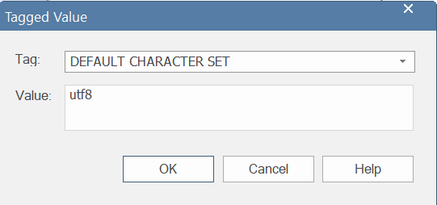

В Sparx Enterprise Architect задать кодировку можно через tagged values таблицы.

1. Настройка метода доступа

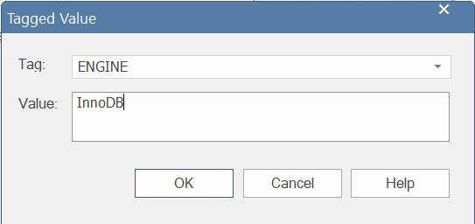

InnoDB механизм хранения является в MySQL механизмом хранения по умолчанию. Если не будет сконфигурирован иной механизм хранения значения, [CREATE TABLE](http://www.rldp.ru/mysql/mysql80/sql.htm#create-table) без предложения ENGINE= создает таблицу InnoDB. Однако не стоит полагаться на настройки по умолчанию, лучше задать метод доступа явно. В Sparx Enterprise Architect это можно сделать через tagged values таблиц.

SQL-код таблицы с явно заданным методом доступа и кодировкой выглядит следующим образом:

CREATE TABLE `address`

(

`address_id` BIGINT UNSIGNED NOT NULL AUTO_INCREMENT,

`country_id` TINYINT UNSIGNED NOT NULL,

`locality_id` INT UNSIGNED NOT NULL,

`street_id` BIGINT UNSIGNED NOT NULL,

`address_building_number` VARCHAR(4) NOT NULL,

`address_apartment_number` SMALLINT UNSIGNED NULL,

CONSTRAINT `PK_addresses` PRIMARY KEY (`address_id` ASC)

)

ENGINE=InnoDB

DEFAULT CHARACTER SET = utf8

;

1. Добавление индексов

Помимо автоматически сгенерированных индексов были добавлены следующие:

1. IX_tour_name – для ускорения поиска по названию тура
2. IX_tour_cost – для ускорения поиска по цене тура
3. IX_tour_name_tour_cost – для ускорения поиска по названию и цене
4. IX_FAQ_question – для ускорения поиска по вопросу
5. IX_tour_date_departure_date – для ускорения поиска по дате отъезда
6. IX_tour_date_tour_id_departure_date – для ускорения поиска по идентификатору тура и дате отъезда
7. IX_user_last_name_first_name_email_phone_number – для ускорения поиска по фамилии, имени, почте, номеру телефона
8. IX_user_passport – для ускорения поиска по номеру паспорта

SQL-код создания индексов:

ALTER TABLE `tour`

ADD INDEX `IX_tour_cost` (`tour_cost` ASC)

;

ALTER TABLE `tour`

ADD INDEX `IX_tour_name` (`tour_name` ASC)

;

ALTER TABLE `tour`

ADD INDEX `IX_tour_name_tour_cost` (`tour_name` ASC, `tour_cost` ASC)

;

ALTER TABLE `FAQ`

ADD INDEX `IX_FAQ_question` (`FAQ_question` ASC)

;

ALTER TABLE `tour_date`

ADD INDEX `IX_tour_date_departure_date` (`tour_date_departure_date` ASC)

;

ALTER TABLE `tour_date`

ADD INDEX `IX_tour_date_tour_id_departure_date` (`tour_id` ASC, `tour_date_departure_date` ASC)

;

Даталогическая схема созданной базы данных:

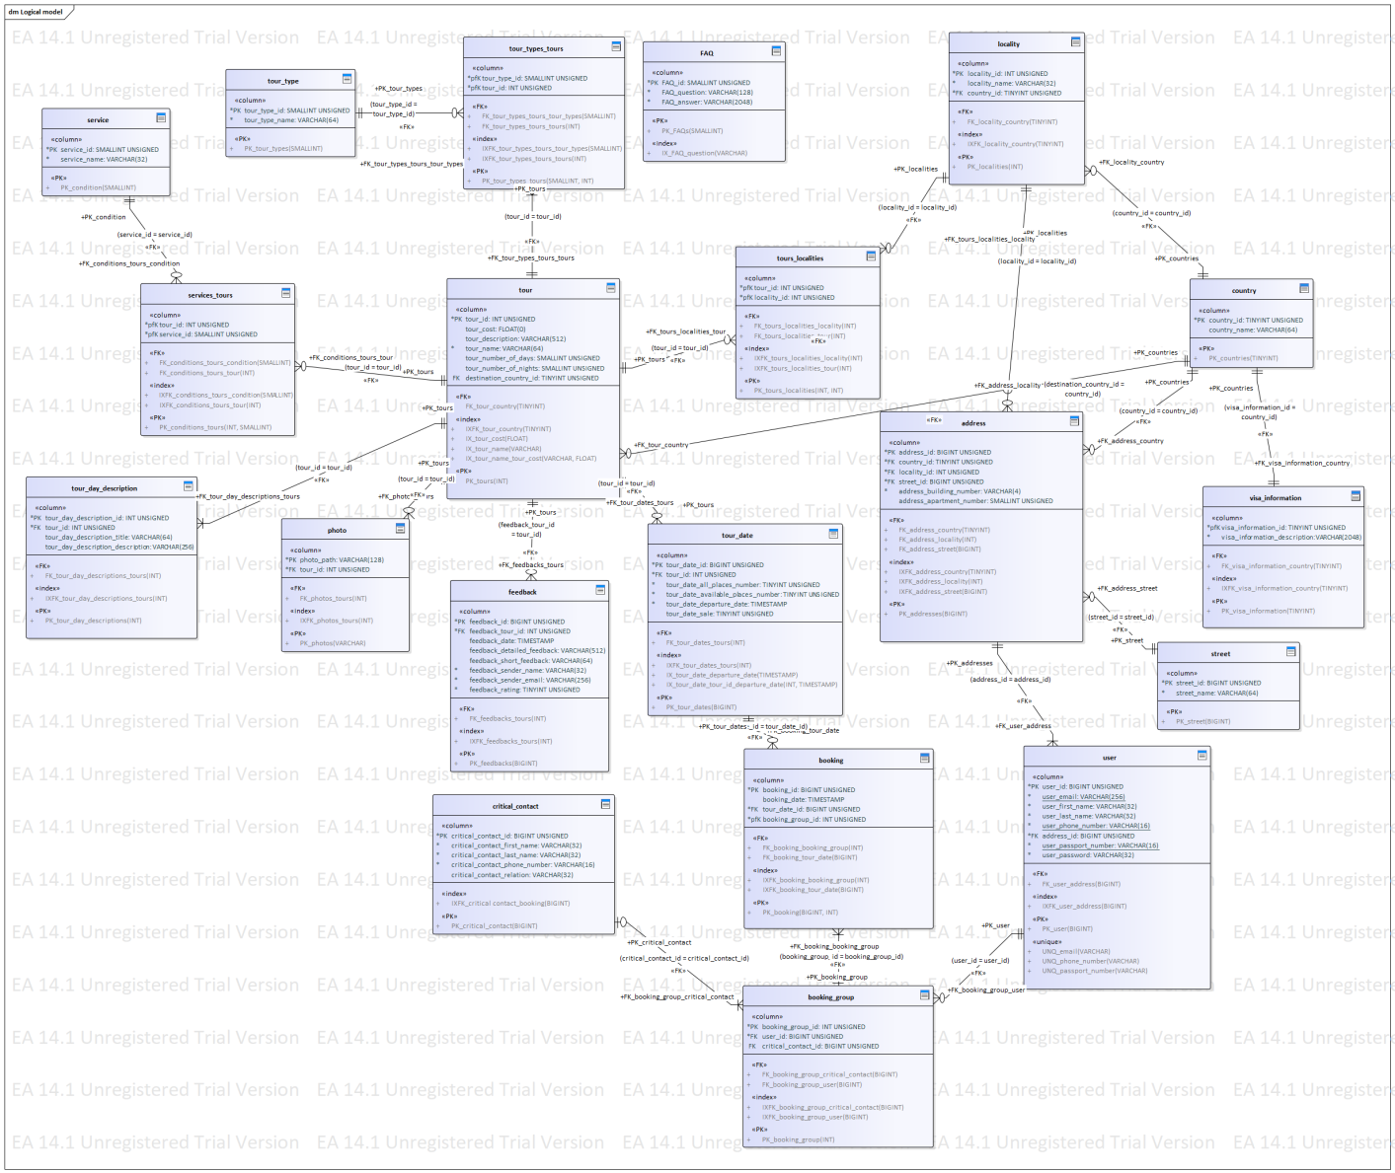

SQL-код создания таблиц:

SET FOREIGN_KEY_CHECKS=0

;

/* Drop Tables */

DROP TABLE IF EXISTS `address` CASCADE

;

DROP TABLE IF EXISTS `booking` CASCADE

;

DROP TABLE IF EXISTS `booking_group` CASCADE

;

DROP TABLE IF EXISTS `country` CASCADE

;

DROP TABLE IF EXISTS `critical_contact` CASCADE

;

DROP TABLE IF EXISTS `FAQ` CASCADE

;

DROP TABLE IF EXISTS `feedback` CASCADE

;

DROP TABLE IF EXISTS `locality` CASCADE

;

DROP TABLE IF EXISTS `photo` CASCADE

;

DROP TABLE IF EXISTS `service` CASCADE

;

DROP TABLE IF EXISTS `services_tours` CASCADE

;

DROP TABLE IF EXISTS `street` CASCADE

;

DROP TABLE IF EXISTS `tour` CASCADE

;

DROP TABLE IF EXISTS `tour_date` CASCADE

;

DROP TABLE IF EXISTS `tour_day_description` CASCADE

;

DROP TABLE IF EXISTS `tour_type` CASCADE

;

DROP TABLE IF EXISTS `tour_types_tours` CASCADE

;

DROP TABLE IF EXISTS `tours_localities` CASCADE

;

DROP TABLE IF EXISTS `user` CASCADE

;

DROP TABLE IF EXISTS `visa_information` CASCADE

;

/* Create Tables */

CREATE TABLE `address`

(

`address_id` BIGINT UNSIGNED NOT NULL AUTO_INCREMENT,

`country_id` TINYINT UNSIGNED NOT NULL,

`locality_id` INT UNSIGNED NOT NULL,

`street_id` BIGINT UNSIGNED NOT NULL,

`address_building_number` VARCHAR(4) NOT NULL,

`address_apartment_number` SMALLINT UNSIGNED NULL,

CONSTRAINT `PK_addresses` PRIMARY KEY (`address_id` ASC)

)

ENGINE=InnoDB

DEFAULT CHARACTER SET = utf8

;

CREATE TABLE `booking`

(

`booking_id` BIGINT UNSIGNED NOT NULL AUTO_INCREMENT,

`booking_date` TIMESTAMP NULL,

`tour_date_id` BIGINT UNSIGNED NOT NULL,

`booking_group_id` INT UNSIGNED NOT NULL,

CONSTRAINT `PK_booking` PRIMARY KEY (`booking_id` ASC, `booking_group_id` ASC)

)

ENGINE=InnoDB

DEFAULT CHARACTER SET = utf8

;

CREATE TABLE `booking_group`

(

`booking_group_id` INT UNSIGNED NOT NULL AUTO_INCREMENT,

`user_id` BIGINT UNSIGNED NOT NULL,

`critical_contact_id` BIGINT UNSIGNED NULL,

CONSTRAINT `PK_booking_group` PRIMARY KEY (`booking_group_id` ASC)

)

ENGINE=InnoDB

DEFAULT CHARACTER SET = utf8

;

CREATE TABLE `country`

(

`country_id` TINYINT UNSIGNED NOT NULL AUTO_INCREMENT,

`country_name` VARCHAR(64) NULL,

CONSTRAINT `PK_countries` PRIMARY KEY (`country_id` ASC)

)

ENGINE=InnoDB

DEFAULT CHARACTER SET = utf8

;

CREATE TABLE `critical_contact`

(

`critical_contact_id` BIGINT UNSIGNED NOT NULL AUTO_INCREMENT,

`critical_contact_first_name` VARCHAR(32) NOT NULL,

`critical_contact_last_name` VARCHAR(32) NOT NULL,

`critical_contact_phone_number` VARCHAR(16) NOT NULL,

`critical_contact_relation` VARCHAR(32) NULL,

CONSTRAINT `PK_critical_contact` PRIMARY KEY (`critical_contact_id` ASC)

)

ENGINE=InnoDB

DEFAULT CHARACTER SET = utf8

;

CREATE TABLE `FAQ`

(

`FAQ_id` SMALLINT UNSIGNED NOT NULL AUTO_INCREMENT,

`FAQ_question` VARCHAR(128) NOT NULL,

`FAQ_answer` VARCHAR(2048) NOT NULL,

CONSTRAINT `PK_FAQs` PRIMARY KEY (`FAQ_id` ASC)

)

ENGINE=InnoDB

DEFAULT CHARACTER SET = utf8

;

CREATE TABLE `feedback`

(

`feedback_id` BIGINT UNSIGNED NOT NULL AUTO_INCREMENT,

`feedback_tour_id` INT UNSIGNED NOT NULL,

`feedback_date` TIMESTAMP NULL,

`feedback_detailed_feedback` VARCHAR(512) NULL,

`feedback_short_feedback` VARCHAR(64) NULL,

`feedback_sender_name` VARCHAR(32) NOT NULL,

`feedback_sender_email` VARCHAR(256) NOT NULL,

`feedback_rating` TINYINT UNSIGNED NOT NULL,

CONSTRAINT `PK_feedbacks` PRIMARY KEY (`feedback_id` ASC)

)

ENGINE=InnoDB

DEFAULT CHARACTER SET = utf8

;

CREATE TABLE `locality`

(

`locality_id` INT UNSIGNED NOT NULL AUTO_INCREMENT,

`locality_name` VARCHAR(32) NOT NULL,

`country_id` TINYINT UNSIGNED NOT NULL,

CONSTRAINT `PK_localities` PRIMARY KEY (`locality_id` ASC)

)

ENGINE=InnoDB

DEFAULT CHARACTER SET = utf8

;

CREATE TABLE `photo`

(

`photo_path` VARCHAR(128) NOT NULL,

`tour_id` INT UNSIGNED NOT NULL,

CONSTRAINT `PK_photos` PRIMARY KEY (`photo_path` ASC)

)

ENGINE=InnoDB

DEFAULT CHARACTER SET = utf8

;

CREATE TABLE `service`

(

`service_id` SMALLINT UNSIGNED NOT NULL AUTO_INCREMENT,

`service_name` VARCHAR(32) NOT NULL,

CONSTRAINT `PK_condition` PRIMARY KEY (`service_id` ASC)

)

ENGINE=InnoDB

DEFAULT CHARACTER SET = utf8

;

CREATE TABLE `services_tours`

(

`tour_id` INT UNSIGNED NOT NULL,

`service_id` SMALLINT UNSIGNED NOT NULL,

CONSTRAINT `PK_conditions_tours` PRIMARY KEY (`tour_id` ASC, `service_id` ASC)

)

ENGINE=InnoDB

DEFAULT CHARACTER SET = utf8

;

CREATE TABLE `street`

(

`street_id` BIGINT UNSIGNED NOT NULL AUTO_INCREMENT,

`street_name` VARCHAR(64) NOT NULL,

CONSTRAINT `PK_street` PRIMARY KEY (`street_id` ASC)

)

ENGINE=InnoDB

DEFAULT CHARACTER SET = utf8

;

CREATE TABLE `tour`

(

`tour_id` INT UNSIGNED NOT NULL AUTO_INCREMENT,

`tour_cost` FLOAT(0,0) UNSIGNED NULL,

`tour_description` VARCHAR(512) NULL,

`tour_name` VARCHAR(64) NOT NULL,

`tour_number_of_days` SMALLINT UNSIGNED NULL,

`tour_number_of_nights` SMALLINT UNSIGNED NULL,

`destination_country_id` TINYINT UNSIGNED NULL,

CONSTRAINT `PK_tours` PRIMARY KEY (`tour_id` ASC)

)

ENGINE=InnoDB

DEFAULT CHARACTER SET = utf8

;

CREATE TABLE `tour_date`

(

`tour_date_id` BIGINT UNSIGNED NOT NULL AUTO_INCREMENT,

`tour_id` INT UNSIGNED NOT NULL,

`tour_date_all_places_number` TINYINT UNSIGNED NOT NULL,

`tour_date_available_places_number` TINYINT UNSIGNED NOT NULL,

`tour_date_departure_date` TIMESTAMP NOT NULL,

`tour_date_sale` TINYINT UNSIGNED NULL,

CONSTRAINT `PK_tour_dates` PRIMARY KEY (`tour_date_id` ASC)

)

ENGINE=InnoDB

DEFAULT CHARACTER SET = utf8

;

CREATE TABLE `tour_day_description`

(

`tour_day_description_id` INT UNSIGNED NOT NULL AUTO_INCREMENT,

`tour_id` INT UNSIGNED NOT NULL,

`tour_day_description_title` VARCHAR(64) NULL,

`tour_day_description_description` VARCHAR(256) NULL,

CONSTRAINT `PK_tour_day_descriptions` PRIMARY KEY (`tour_day_description_id` ASC)

)

ENGINE=InnoDB

DEFAULT CHARACTER SET = utf8

;

CREATE TABLE `tour_type`

(

`tour_type_id` SMALLINT UNSIGNED NOT NULL AUTO_INCREMENT,

`tour_type_name` VARCHAR(64) NOT NULL,

CONSTRAINT `PK_tour_types` PRIMARY KEY (`tour_type_id` ASC)

)

ENGINE=InnoDB

DEFAULT CHARACTER SET = utf8

;

CREATE TABLE `tour_types_tours`

(

`tour_type_id` SMALLINT UNSIGNED NOT NULL,

`tour_id` INT UNSIGNED NOT NULL,

CONSTRAINT `PK_tour_types_tours` PRIMARY KEY (`tour_type_id` ASC, `tour_id` ASC)

)

ENGINE=InnoDB

DEFAULT CHARACTER SET = utf8

;

CREATE TABLE `tours_localities`

(

`tour_id` INT UNSIGNED NOT NULL,

`locality_id` INT UNSIGNED NOT NULL,

CONSTRAINT `PK_tours_localities` PRIMARY KEY (`tour_id` ASC, `locality_id` ASC)

)

ENGINE=InnoDB

DEFAULT CHARACTER SET = utf8

;

CREATE TABLE `user`

(

`user_id` BIGINT UNSIGNED NOT NULL AUTO_INCREMENT,

`user_email` VARCHAR(256) NOT NULL,

`user_first_name` VARCHAR(32) NOT NULL,

`user_last_name` VARCHAR(32) NOT NULL,

`user_phone_number` VARCHAR(16) NOT NULL,

`address_id` BIGINT UNSIGNED NOT NULL,

`user_passport_number` VARCHAR(16) NOT NULL,

`user_password` VARCHAR(32) NOT NULL,

CONSTRAINT `PK_user` PRIMARY KEY (`user_id` ASC)

)

ENGINE=InnoDB

DEFAULT CHARACTER SET = utf8

;

CREATE TABLE `visa_information`

(

`visa_information_id` TINYINT UNSIGNED NOT NULL,

`visa_information_description` VARCHAR(2048) NOT NULL,

CONSTRAINT `PK_visa_information` PRIMARY KEY (`visa_information_id` ASC)

)

ENGINE=InnoDB

DEFAULT CHARACTER SET = utf8

;

/* Create Primary Keys, Indexes, Uniques, Checks */

ALTER TABLE `address`

ADD INDEX `IXFK_address_country` (`country_id` ASC)

;

ALTER TABLE `address`

ADD INDEX `IXFK_address_locality` (`locality_id` ASC)

;

ALTER TABLE `address`

ADD INDEX `IXFK_address_street` (`street_id` ASC)

;

ALTER TABLE `booking`

ADD INDEX `IXFK_booking_booking_group` (`booking_group_id` ASC)

;

ALTER TABLE `booking`

ADD INDEX `IXFK_booking_tour_date` (`tour_date_id` ASC)

;

ALTER TABLE `booking_group`

ADD INDEX `IXFK_booking_group_critical_contact` (`critical_contact_id` ASC)

;

ALTER TABLE `booking_group`

ADD INDEX `IXFK_booking_group_user` (`user_id` ASC)

;

ALTER TABLE `critical_contact`

ADD INDEX `IXFK_critical contact_booking` (`critical_contact_id` ASC)

;

ALTER TABLE `FAQ`

ADD INDEX `IX_FAQ_question` (`FAQ_question` ASC)

;

ALTER TABLE `feedback`

ADD INDEX `IXFK_feedbacks_tours` (`feedback_tour_id` ASC)

;

ALTER TABLE `locality`

ADD INDEX `IXFK_locality_country` (`country_id` ASC)

;

ALTER TABLE `photo`

ADD INDEX `IXFK_photos_tours` (`tour_id` ASC)

;

ALTER TABLE `services_tours`

ADD INDEX `IXFK_conditions_tours_condition` (`service_id` ASC)

;

ALTER TABLE `services_tours`

ADD INDEX `IXFK_conditions_tours_tour` (`tour_id` ASC)

;

ALTER TABLE `tour`

ADD INDEX `IXFK_tour_country` (`destination_country_id` ASC)

;

ALTER TABLE `tour`

ADD INDEX `IX_tour_cost` (`tour_cost` ASC)

;

ALTER TABLE `tour`

ADD INDEX `IX_tour_name` (`tour_name` ASC)

;

ALTER TABLE `tour`

ADD INDEX `IX_tour_name_tour_cost` (`tour_name` ASC, `tour_cost` ASC)

;

ALTER TABLE `tour_date`

ADD INDEX `IXFK_tour_dates_tours` (`tour_id` ASC)

;

ALTER TABLE `tour_date`

ADD INDEX `IX_tour_date_departure_date` (`tour_date_departure_date` ASC)

;

ALTER TABLE `tour_date`

ADD INDEX `IX_tour_date_tour_id_departure_date` (`tour_id` ASC, `tour_date_departure_date` ASC)

;

ALTER TABLE `tour_day_description`

ADD INDEX `IXFK_tour_day_descriptions_tours` (`tour_id` ASC)

;

ALTER TABLE `tour_types_tours`

ADD INDEX `IXFK_tour_types_tours_tour_types` (`tour_type_id` ASC)

;

ALTER TABLE `tour_types_tours`

ADD INDEX `IXFK_tour_types_tours_tours` (`tour_id` ASC)

;

ALTER TABLE `tours_localities`

ADD INDEX `IXFK_tours_localities_locality` (`locality_id` ASC)

;

ALTER TABLE `tours_localities`

ADD INDEX `IXFK_tours_localities_tour` (`tour_id` ASC)

;

ALTER TABLE `user`

ADD CONSTRAINT `UNQ_email` UNIQUE (`user_email` ASC)

;

ALTER TABLE `user`

ADD CONSTRAINT `UNQ_phone_number` UNIQUE (`user_phone_number` ASC)

;

ALTER TABLE `user`

ADD CONSTRAINT `UNQ_passport_number` UNIQUE (`user_passport_number` ASC)

;

ALTER TABLE `user`

ADD INDEX `IXFK_user_address` (`address_id` ASC)

;

ALTER TABLE `visa_information`

ADD INDEX `IXFK_visa_information_country` (`visa_information_id` ASC)

;

/* Create Foreign Key Constraints */

ALTER TABLE `address`

ADD CONSTRAINT `FK_address_country`

FOREIGN KEY (`country_id`) REFERENCES `country` (`country_id`) ON DELETE Restrict ON UPDATE Cascade

;

ALTER TABLE `address`

ADD CONSTRAINT `FK_address_locality`

FOREIGN KEY (`locality_id`) REFERENCES `locality` (`locality_id`) ON DELETE Restrict ON UPDATE Cascade

;

ALTER TABLE `address`

ADD CONSTRAINT `FK_address_street`

FOREIGN KEY (`street_id`) REFERENCES `street` (`street_id`) ON DELETE Restrict ON UPDATE Cascade

;

ALTER TABLE `booking`

ADD CONSTRAINT `FK_booking_booking_group`

FOREIGN KEY (`booking_group_id`) REFERENCES `booking_group` (`booking_group_id`) ON DELETE Cascade ON UPDATE Cascade

;

ALTER TABLE `booking`

ADD CONSTRAINT `FK_booking_tour_date`

FOREIGN KEY (`tour_date_id`) REFERENCES `tour_date` (`tour_date_id`) ON DELETE Restrict ON UPDATE Cascade

;

ALTER TABLE `booking_group`

ADD CONSTRAINT `FK_booking_group_critical_contact`

FOREIGN KEY (`critical_contact_id`) REFERENCES `critical_contact` (`critical_contact_id`) ON DELETE Restrict ON UPDATE Cascade

;

ALTER TABLE `booking_group`

ADD CONSTRAINT `FK_booking_group_user`

FOREIGN KEY (`user_id`) REFERENCES `user` (`user_id`) ON DELETE Restrict ON UPDATE Cascade

;

ALTER TABLE `feedback`

ADD CONSTRAINT `FK_feedbacks_tours`

FOREIGN KEY (`feedback_tour_id`) REFERENCES `tour` (`tour_id`) ON DELETE Cascade ON UPDATE Cascade

;

ALTER TABLE `locality`

ADD CONSTRAINT `FK_locality_country`

FOREIGN KEY (`country_id`) REFERENCES `country` (`country_id`) ON DELETE Restrict ON UPDATE Cascade

;

ALTER TABLE `photo`

ADD CONSTRAINT `FK_photos_tours`

FOREIGN KEY (`tour_id`) REFERENCES `tour` (`tour_id`) ON DELETE Cascade ON UPDATE Cascade

;

ALTER TABLE `services_tours`

ADD CONSTRAINT `FK_conditions_tours_condition`

FOREIGN KEY (`service_id`) REFERENCES `service` (`service_id`) ON DELETE Cascade ON UPDATE Cascade

;

ALTER TABLE `services_tours`

ADD CONSTRAINT `FK_conditions_tours_tour`

FOREIGN KEY (`tour_id`) REFERENCES `tour` (`tour_id`) ON DELETE Cascade ON UPDATE Cascade

;

ALTER TABLE `tour`

ADD CONSTRAINT `FK_tour_country`

FOREIGN KEY (`destination_country_id`) REFERENCES `country` (`country_id`) ON DELETE Restrict ON UPDATE Cascade

;

ALTER TABLE `tour_date`

ADD CONSTRAINT `FK_tour_dates_tours`

FOREIGN KEY (`tour_id`) REFERENCES `tour` (`tour_id`) ON DELETE Cascade ON UPDATE Cascade

;

ALTER TABLE `tour_day_description`

ADD CONSTRAINT `FK_tour_day_descriptions_tours`

FOREIGN KEY (`tour_id`) REFERENCES `tour` (`tour_id`) ON DELETE Cascade ON UPDATE Cascade

;

ALTER TABLE `tour_types_tours`

ADD CONSTRAINT `FK_tour_types_tours_tour_types`

FOREIGN KEY (`tour_type_id`) REFERENCES `tour_type` (`tour_type_id`) ON DELETE Cascade ON UPDATE Cascade

;

ALTER TABLE `tour_types_tours`

ADD CONSTRAINT `FK_tour_types_tours_tours`

FOREIGN KEY (`tour_id`) REFERENCES `tour` (`tour_id`) ON DELETE Cascade ON UPDATE Cascade

;

ALTER TABLE `tours_localities`

ADD CONSTRAINT `FK_tours_localities_locality`

FOREIGN KEY (`locality_id`) REFERENCES `locality` (`locality_id`) ON DELETE Restrict ON UPDATE Cascade

;

ALTER TABLE `tours_localities`

ADD CONSTRAINT `FK_tours_localities_tour`

FOREIGN KEY (`tour_id`) REFERENCES `tour` (`tour_id`) ON DELETE Cascade ON UPDATE Cascade

;

ALTER TABLE `user`

ADD CONSTRAINT `FK_user_address`

FOREIGN KEY (`address_id`) REFERENCES `address` (`address_id`) ON DELETE Restrict ON UPDATE Cascade

;

ALTER TABLE `visa_information`

ADD CONSTRAINT `FK_visa_information_country`

FOREIGN KEY (`visa_information_id`) REFERENCES `country` (`country_id`) ON DELETE Cascade ON UPDATE Cascade

;

SET FOREIGN_KEY_CHECKS=1

;